**Assignment 9**

**Branch Creation & Switching**

**Create a new branch named 'feature' and switch to it. Make changes in the 'feature' branch and commit them.**

Step 1: Create & Switch to new branch in one command.

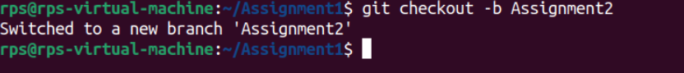

Step 2: Make a Commit after file adding to staging area.

